St. Paul

Friends of Playschool

Handbook

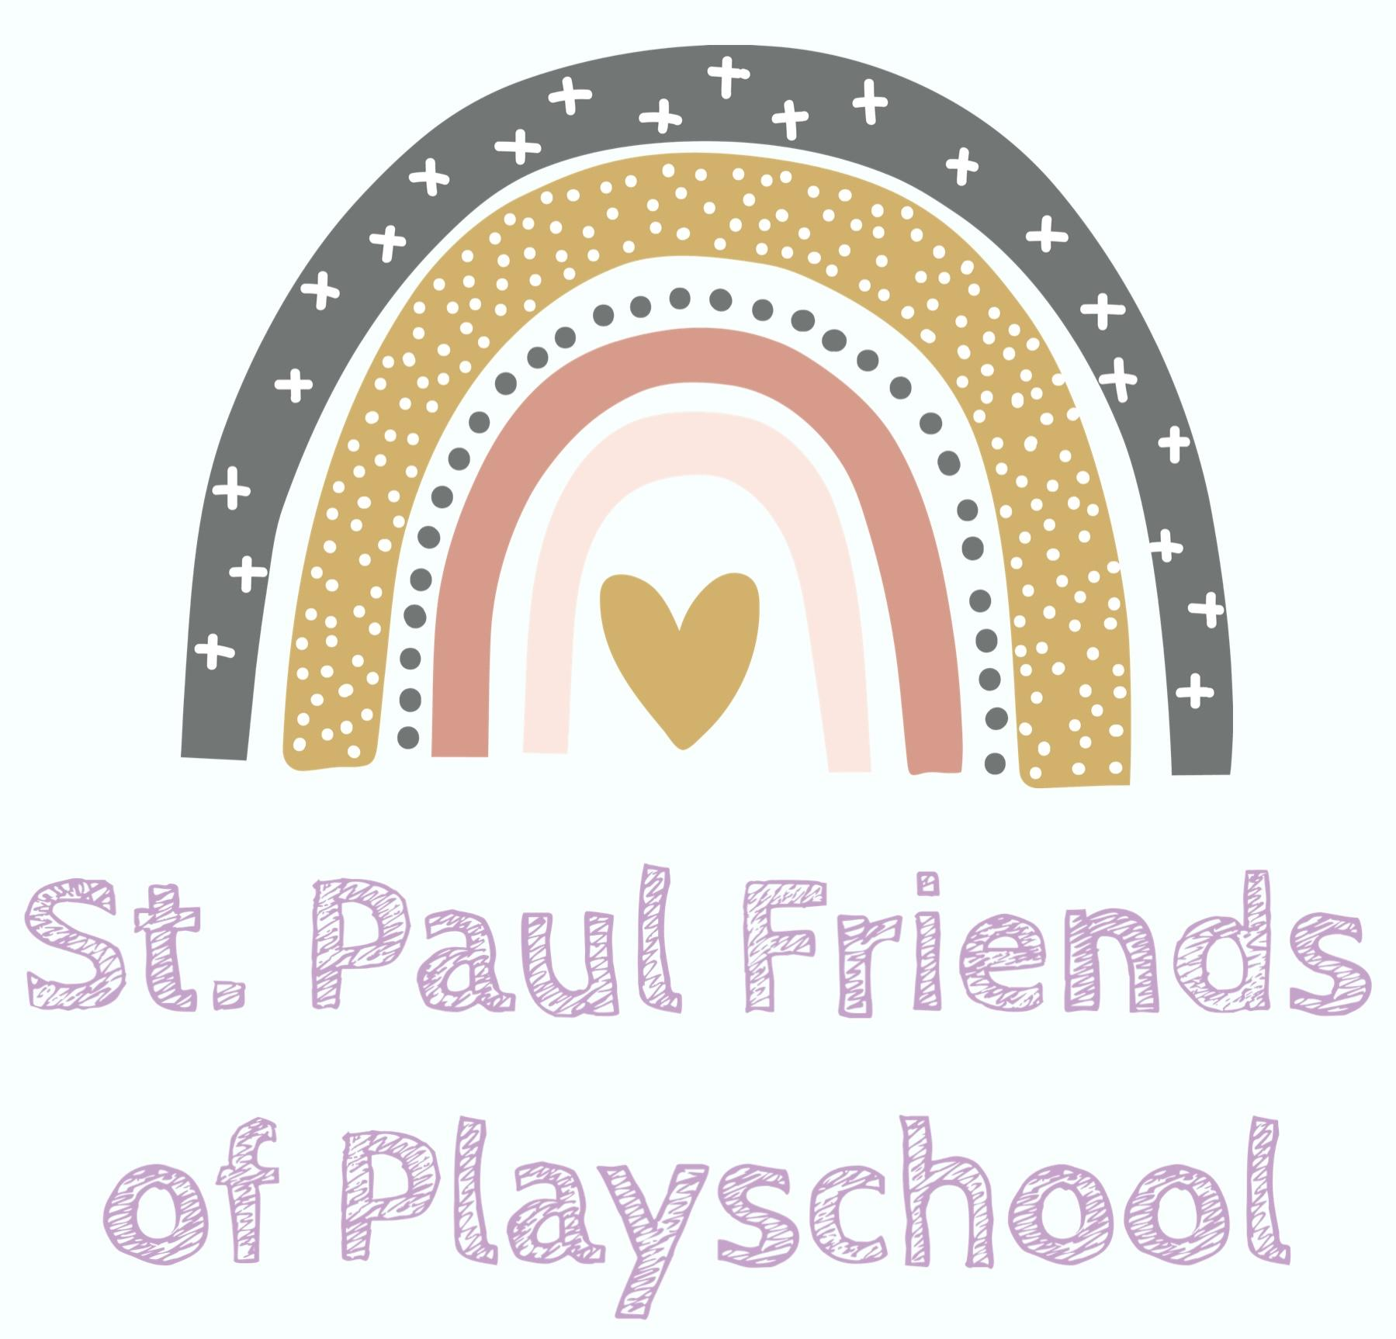

**OUR SCHOOL PHILOSOPHY**

*We, the St. Paul Friends of Playschool staff, recognize and appreciate the uniqueness of each member of our school community. We will guide and assist our students to be the best they can be socially, physically, intellectually, creatively, culturally and emotionally within an atmosphere of warmth and togetherness, care and concern, respect and trust.*

Playschool is operated and administered by The Friends of Playschool Society. We are a non-profit organization. Funding is provided through membership fees, fundraising activities and donations. Programming is centered around the Child Care Licensing Regulation of Alberta.

The aims of Playschool are to:

- integrate all aspects of its program into a meaningful whole;

- utilize parents, school and community resources;

- create a total learning environment for each child

- provide opportunities for which parents gain useful information towards understanding their child's social, intellectual, physical, cultural, and emotional development.

Playschool is a bridge between the home and the school, and a place where the child can have experiences that will help develop good attitudes, habits and skills. These abilities will help the child meet new situations with confidence. The aim of the program in St. Paul is to provide an environment that promotes the growth of the whole child - socially, physically, intellectually, creatively, culturally and emotionally. Our philosophy of learning through play is accomplished through the use of activity centers.

**1. Social Development**

- cooperation and sharing

- sensitive to the feelings of others

- adapts easily to different situations

- participates freely in small/large group settings

- makes decisions and is developing individuality

- has responsibility towards groups requirements/routines

- uses courteous habits and is developing manners

**2. Physical Development**

- large motor skills (jumping, skipping, balancing)

- small motor skills (drawing, tracing, cutting, pasting)

- coordination (hand-eye, eye-foot, etc.), throwing, catching, kicking balls, threading

- awareness of body parts and their uses

- awareness of body's physical needs (rest, exercise, bathing, grooming, nutrition, dress to suit weather conditions)

- awareness of space and direction

**3. Intellectual Development**

General skills achieved through the integration of Mathematics, Science, Language, Physical Education, Art, Drama, Music, Library, Nutrition, Kinder Cooking, Carpentry, Field Trips

- develops curiosity and a desire to learn

- learns to acquire information through observation, ordering, classification, measurement, investigation

- transfers skills and information from one situation to another

- compares facts and inferences to acquire understanding

Opportunities will be provided for the development and practice of:

- auditory skills

- visual skills

- comprehension skills

- listening skills

- speaking skills

- pre-reading skills (classifying, likeness, differences)

- numbering skills

- science and health skills

**4. Cultural/Social Development**

- broadening of interest and involvement in the cultural arts, i.e. literature, music, drama, movement and dance, and the visual arts

- learning to understand and appreciate a diversity of cultural backgrounds

**5. Emotional Development**

- self confidence

- self discipline

- self motivation

- self direction

- self worth and dignity

- develop trust and value in themselves and others

- meets new experiences and settings with confidence

**Program Information**

Playschool classes are held two half days per week. Morning and afternoon classes may be available depending on enrollment.

Children need to be 3 ½ by December 31 of the current school year to enroll.

**Toileting Procedures**

The Playschool children shall be responsible for their toilet needs. They are required to use the toilet on their own, wipe themselves and pull up their clothing. The necessary preventative health practices of hand washing after toileting shall be developed and maintained.

A change of clothes should be kept in your child’s backpack at all times.

**SCHOOL DAY SCHEDULE**

**9:00 - 11:30 a.m.** A.M. class

**11:30 - 12:30 p.m.** Lunch and prep time

**12:30 p.m.** Doors opened for P.M. class.

**12:30- 3:00 p.m.** P.M. class

Children should not arrive at Playschool prior to 9:00 a.m. for the morning classes and 12:30 p.m. for the afternoon classes unless other arrangements have been made with your child's teacher.

**\*DO NOT BRING YOUR CHILD MORE THAN FIVE MINUTES AHEAD OF THE TIME AND PLEASE PICK THEM UP ON TIME UNLESS SPECIAL ARRANGEMENTS HAVE BEEN MADE WITH THE TEACHER**\*

**THE PLAYSCHOOL DAY**

**1. Teacher Directed Activity**

a) For visual, auditory and motor development

b) Introduction of Math and scientific concepts

c) Social Studies concepts

d) Music activities

e) Special sessions, i.e. visitors, cooking, movies, etc.

**2. Self-Selected Activity - (Centers)**

a) Arts and Crafts - painting, coloring, constructing

b) Listening - story books, tapes, records, flannel board

c) Blocks - animals, blocks, small-wheeled toys

d) Manipulative - puzzles, small blocks, matching games

e) Playhouse and Dollhouse - role playing

f) Reading - books, words

g) Math - numbers, one to one correspondence

h) Water Table - sensory experiences, toys, bottles

i) Sand - construction, sensual experiences

j) Craft - working with teacher and small groups

k) Writing - picture-word association

1. Science - experiments, animals, plants

**3. Clean-up and Relaxation**

a) Picking up and storing books, blocks, puzzles, etc.

b) Tidying the playhouse and role playing centers

c) Wiping up spills

d) Resting bodies, listening to music

**4. Gym Self-Selected Activities**

a) Large muscle - climbing, swinging, pushing, pulling

b) Small apparatus - balls, bean bags, ropes, hoops

c) Dance - body awareness, shape

d) Games - eye-hand, eye-foot coordination

**5. Outside Playtime**

**6. Refreshments and Conversation Time**

**7. Language Arts**

a) Dramatic stories

b) Discuss pictures or objects

c) Make up and tell original stories

d) Musical activities (songs, instruments, etc.)

**8. Dress to go Home**

Children shall show respect towards themselves, other children, the teachers,

parents and property of others. They will refrain from teasing and rough play (pretend gun games.) Abusive and profane language is prohibited.

Appropriate dress is required at all times:

a) Shoes must be worn inside the classroom and gym area at all times.

b) Outdoor footwear must be worn to play outside on all days when there is snow or mud.

c) During the winter months, children must dress warmly in case of any emergencies and also in order to play outside comfortably.

d) No outdoor footwear is to be worn inside the classroom.

e) Please write your child's name on all of their outdoor clothing, boots, and personal articles so they can be easily found and identified when they are misplaced.

f) Children are expected to wear clothing appropriate for attending school. They should be dressed modestly.

A signed, dated note from parents is requested:

a) When there is a change in the usual routine e.g. - child is going home with another adult.

b) To explain reasons for absence or delay in getting to Playschool.

Telephone Calls

c) The telephone number for St. Paul Regional High School is 780-645-4491. Teacher’s Cell is 780-872-3446

d) Student Absentee: Please contact us via Seesaw or email at st.paulfriendsofplayschool@gmail.com.

## BEHAVIOR MANAGEMENT POLICY

The primary goal of our behavior management methods is to help the child internalize coping mechanisms and develop self-esteem. Methods chosen will recognize individual differences and so vary depending on the situation and the child.

1. Preventive Measures:

a) Guidelines to promote independence and minimum intervention.

1. Communicating clear rules and behavior and expectations.
2. Ensuring staff and supervising parents at all times serve as a positive role model for expected behavior.
3. Positive reinforcement of appropriate behavior.

2. Intervention Measures: Should behavior extend beyond the established classroom limits the

following steps will be taken:

1. Logical consequences- letting the child experience the consequences of his actions.
2. Speak to the child explaining acceptable behavior. The child will be encouraged to solve his own problem and to participate in an appropriate manner.
3. If the behavior continues and is disrupting the class, the child will be transferred under direct supervision and support, from the play area until they are ready to participate appropriately.
4. In extreme circumstances, parents will be contacted.

# 

**DUTIES OF THE PLAYSCHOOL INSTRUCTOR**

An instructor employed by the St. Paul Friends of Playschool shall:

1. Be familiar with the program Handbook, the Act, Regulation, and all

administrative policies and procedures.

2. Develop and deliver a program which meets the developmental needs of all children. In addition, develop long range plans for the progress of children.

3. Be responsible for the day to day implementation of the program and curriculum. Daily plans must show dates, times, center activities and objectives. Daily plan books must be open at all times so the parents can see what we have done on previous days, the current day and following days. They will also explain to the helping parent what assistance is required (when applicable). The teacher is to help develop the six “selves” of each child in day-to-day activities.

**SOCIAL:** By greeting and interacting with the children.

**PHYSICAL:** By providing indoor or outdoor activities as well as games, free play and action songs.

**LANGUAGE:** By having group activities, stories, snacks and songs.

**INTELLECTUAL:** By having teacher and child directed activities, puzzles and manipulative play.

**CREATIVE:** By having free play, art, sand & water centers, working with puppets.

**EMOTIONAL:** By interacting with other children, stories, games, show and tell. Give encouragement and praise when improvement is noticed.

# CODE OF ETHICS

1. The teacher is courteous, just and professional in all relationships.

2. All documents and testimonials presented by a teacher are truthful and confidential.

3. The teacher strives constantly to improve his/her educational practice.

4. Contracts are respected by both parties and dissolved only by mutual consent in accordance to the terms prescribed by the statute.

5. Each teacher is an active participant in the work of his/her professional organization.

6. No teacher accepts compensation for helping another teacher to get a position or promotion.

7. Unfavorable criticism of an associate is studiously avoided except when made to proper officials, and then only in confidence and after the associate has been informed of the nature of the criticism.

8. The teacher regards as confidential and does not divulge other than through official channels, any information of a personal or domestic nature, concerning either pupils or home, obtained in the course of his/her professional duties.

9 Official business is transacted only through properly designated officials.

**Emergency Absence of Playschool Instructor**

If an emergency has arisen where neither the specified Playschool Instructor nor the Classroom assistant are at school when students arrive, the procedure to follow is as follows:

1. Phone the Playschool Instructor, if no answer, phone the Classroom Assistant.

2. If the Classroom Assistant cannot come in, contact a member of the executive. A list will be posted on the outside of the classroom door with names and phone numbers.

**\* * * Do not leave your child/ren until another instructor arrives * * \***

# SNACK PROGRAM

We have snack time at mid-morning for the morning class and mid-afternoon for the afternoon classes. Snack time is usually given at 10:30 am for morning classes and 2:15 pm for afternoon classes.

Parents are responsible for sending 1-2 small snacks. We use snack time to teach certain concepts such as nutrition, measuring, counting, and socializing.

Children will continue taking turns being leaders for the day and are always the first to do things that day.

Food provided by the family to share will need to be prepackaged, store bought snacks. Homemade goods are not allowed. Please notify the teacher before sending any food items to the classroom.

**Allergies:** If children have specific food allergies, this information is posted in the Playschool classroom for the teachers.

**\*\*\*Our school is a nut aware zone\*\*\***

**FIELD TRIPS**

The objectives for field trips/home visits are:

1. To provide activities to which the child can contribute and earn the respect of others.

2. To develop skills of social and group living.

3. To expand the mental and physical horizons of the child through planned activities.

4. The year end field trip is a bonus day, and is therefore up to the discretion of each parent/guardian whether they want to send their child.

A consent form will be sent home prior to the field trip, it must be signed and returned by the due date. Otherwise, your child will not be allowed to participate in the activity.

**ATTENTION! Medication**

**Please Note:** Our licensing policy states: "All medications must be locked." Some forms of medication may be found in purses, we ask that all purses be locked in storage.

The Playschool staff does not administer any kinds of medication.

In case of severe asthma or allergic reaction, medication will be administered if the staff has:

* 1. the written consent of the child’s parent/guardian
  2. the medication is in the original labeled container
  3. the medication is administered according to the labeled directions

**Health Care:**

A license holder may provide or allow for the provision of health care to a child only if

1. The written consent of the child's parent/guardian has been obtained, or
2. The health care provided is in the nature of first aid.

**Incident reporting:**

An incident means a serious illness or injury to a child occurs while the child is attending our program, and any other incident that occurs while a child is attending our program that may seriously affect the health or safety of the child.

A license holder must report each incident to the director forthwith in the manner required by the director.

**Potential Health Risk Policy**

An ill child includes:

- A child who exhibits signs or symptoms of illness including: vomiting, having a high fever, diarrhea or a new or unexplained cough or rash is not permitted to attend the program.

-Requires greater care and attention that can be provided without compromising the care of the other children in the program.

- Has other symptoms that lead a staff member to believe that the child poses a health risk.

If any of these symptoms appear during the class time, the teacher will contact the parents to have the student brought home. The child will be isolated, as reasonably possible, from the other students and supervised by the teacher. Parents are expected to arrange for immediate pick up of their ill child, otherwise, the emergency contact person, will be requested to pick up the ill child. The child may not return to the program, until he/she is symptom free for at least 24 hours or a parent has a physician’s note.

The program will document and record the following:

-name of ill child

-date the child was observed to be ill

-name of the staff person who identified the child was ill and why (e.g. fever, vomiting etc.)

-time the parent was initially contacted and name of staff person who contacted

-time the child was picked up

-the date the child returned to the program

**HEAD LICE POLICY**

The St. Paul Friends of Playschool Society enforces a proactive approach to head lice management. Staff members will provide and announce regular screenings and reminders will be sent the day before. Whenever possible, parents will be notified in advance of any additional screenings.

When a case of head lice or nits is found, the parent(s) will be notified immediately and expected to arrange for prompt pick-up of their child(ren). Infested child(ren) will be removed from the group setting and prepared for pick-up with a minimum of fuss. Students are able to return to school as soon as he/she is free of lice and nits for 2 days following treatment.

All parents will be notified when a case of head lice is detected within the program and arrangements will be made for the entire group to be screened as soon as possible. All dress-up clothing will be immediately removed from the classroom.

Should head lice be detected in two or more students, a lice outbreak may be declared and playschool classes could be canceled until further notice.

# EMERGENCY PROCEDURES

**1. Accidents and Illness**

Minor Accidents - such as nosebleeds, scrapes, and minor cuts are handled by the teachers using paper toweling, or a first-aid kit located in the classroom. Rubber gloves will be worn.

Major Accidents - such as broken bones, possible spine fractures, major cuts requiring sutures, etc., teachers should enlist the assistance of a volunteer person. Emergency assistance will be obtained. Parents should be contacted as soon as possible after a major accident. Accident reports must be filed.

**2.** **Emergency Evacuation Procedures**

Emergency evacuations are practiced often, particularly at the beginning of the school year, to provide an efficient, safe way of evacuating the school in the event of a fire or other emergency.

A fire exit map is provided to each teacher at the beginning of the school year. These should be posted in each room.

It is the teacher's responsibility to become familiar with all emergency procedures and assure that students understand the procedures which are as follows:

- All students must walk quietly at a normal pace, single file.

- Footwear must be worn in school at all times, to accommodate such drills.

- Each homeroom teacher must have a class list. The doors and windows must be closed as he or she leaves.

- All students should be instructed that the first one through the door hold it open for his/her class.

- Each class has a designated exit. If a student is not with his or her class, it is that student's responsibility to exit through the nearest exit and then move quickly to where the rest of the class is assembled.

- Once outside, roll call must be taken. The bell will ring to indicate that re-entry should begin.

- Following each evacuation drill teachers are requested to report any problems to the principal.

- If a child is missing, the teacher is to report to the administrator at the front of the school and the neighboring teacher will supervise the class.

- Arrangements have been made with the Racette School Administration, that in the event of an emergency where we would not be allowed to return to the building, the students and staff would go to Racette for shelter.

**3. Emergency Procedures Off School Property**

The following guidelines are for persons supervising groups of students engaged in activities outside the premises of the school. They apply equally to school staff or volunteers.

In the event of an accident, supervisors will take prompt, effective action to minimize the danger of the students.

**Prior to Departure**:

1. The teacher will determine the location of the nearest medical facility and/or ambulance service and have any necessary telephone numbers.

2. If traveling to a location where first aid supplies are not available, ensure that they have a first aid kit.

3. Ensure that parent/guardian consent forms are obtained for each student making the trip. On the form special conditions of the students will be noted, e.g. allergic reaction to bee stings.

**Building Security**

All doors, with the exception of the main office door, will be locked shortly after 9:00 a.m. and will remain locked during the school day.

#### Lockdown

Teacher will be practicing lockdown procedures with the children. As well as showing them safe rooms.

**En route or on Location of Activity**:

Should an accident occur in which an injury is caused to a student/students or supervisor, these steps will be followed:

1. First aid will be administered.

2. Remove injured people from immediate danger.

3. Notify the medical facility and, if necessary, request an ambulance be dispatched.

4. Notify the school which will, in turn, notify the parents.

5. Accompany injured persons to medical facilities if possible.

**Return to School**:

Immediately upon return to school, a written report should be prepared. The report would include:

1. Nature of incident and causes.

2. Names of students and supervisors in attendance at activity.

3. Names of injured and extent of injuries (as near as can be determined).

4. Any comments and observations you may have.

**Effective Supervision**

When 7 or more children are present at the program, on or off regular program premises, there will be a minimum of 2, adult staff members, which may include a parent volunteer. Adequate supervision will ensure the children’s safety, well-being and development.

This is to be done by:

- regular “head counts” of children

- safety checks of indoor and outdoor environments (toys, playground equipment, etc.)

-avoiding activities that draw away from effective supervision

-positioning to allow for supervision of the entire group

-ensuring play in a safe manner

-monitoring children’s health and behavior

-noticing children and parents arrival and departure

-know which individuals are authorized to pick up a child. Obtain a copy of court order if one parent cannot pick up a child.

-carry portable records and first aid kit, when necessary

-know where emergency medications, first aid kits and emergency records are stored

**INCLEMENT WEATHER**

The Board is concerned about the safe transport of students to and from school. In the

event of inclement weather or hazardous road conditions, should the school division

decide to cancel school bus transportation or close the school, playschool will evaluate the weather conditions and/or to close will solely be up to the teacher discretion. In the event of early school bus dismissal from schools or closing of the school

after the school has opened, parents may be required to pick up their children from playschool early and will be contacted by the Teacher in such an event.

# COVID-19 POLICIES AND PROCEDURES

SCREENING AND RESPONSE PLAN

* Staff, parents and children must not enter the playschool space if they have COVID symptoms.
* Before every shift, child care providers are expected to assess themselves for symptoms of COVID-19 using the Alberta Health Daily Checklist.
* If a child develops symptoms while at the facility, the child will be isolated in a separate room and the parent will be notified to come and pick up the child immediately. If a separate room is not available, the child will be kept at least 2 meters away from other children.
  + If the child is young and requires close contact and care, staff can continue to care for the child until the parent is able to pick up the child. Staff should wear a non-medical mask and eye protection during all interactions with the child.
  + All items, such as bedding, toys etc., used by the child in the 48 hours prior to symptom onset and while isolated will be cleaned and disinfected as soon as the child has been picked up. Items that cannot be cleaned and disinfected (e.g. paper, books, cardboard puzzles) will be removed from the centre and stored in a sealed container for a minimum of 72 hours.
* Proof of a negative COVID-19 test result is not necessary to return to playschool.

ENTERING AND EXITING THE FACILITY

* The designated Playschool entrance will be the North facing doors, beside the gym - there is a sign indicating the Preschool entrance.
* Parents will park in the designated visitor parking and bring their children into the school using the Preschool entrance.
* Pick up and drop off times will be brief and late arrivals will have to enter through front office doors.
* Staff will use telephone or video conferencing when possible to meet with parents.

HAND HYGIENE AND RESPIRATORY ETIQUETTE

* Children will frequently be reminded to follow proper hand hygiene and respiratory etiquette (wash hands frequently, sneeze/cough into their elbow, put used tissues in a waste receptacle and wash hands immediately after using tissues).
* Playschool programs must adhere to handwashing guidelines outlined in the AHS Health and Safety Guidelines Child Care Guidelines. Hand sanitizer containing at least 60% alcohol is recommended as there is evidence that supports effectiveness against COVID-19. Hand sanitizer can help reduce the risk of infection by, or spread of microorganisms when hand washing is not possible. If parents have questions about their child using alcohol-based hand sanitizer they should contact the playschool operator to discuss potential alternatives.
* Access to hand sanitizer will be monitored at all times because it can result in accidental poisoning if ingested. Children will be closely supervised when using alcohol-based hand sanitizer. Manufacturer instructions for each product will be followed.

CLEANING AND DISINFECTING

* Program will engage in frequent, thorough cleaning and disinfecting.
* Frequently touched objects and surfaces will be cleaned and disinfected regularly using bleach water.
* If using a public or school playground, staff will ensure that children engage in hand hygiene before and after play.

ABSENCES/CLOSURES

* Any school days missed due to illness of the student or a family member will not be refunded. If the student or a family member is required to self-isolate for 10-14 days, no refunds will be provided for the school days missed during this time.
* Any school days missed to illness or self-isolation requirements of a staff member, will not be reimbursed.
* In the instance of a mandatory program closure, due to the Covid-19 pandemic or any other circumstance beyond the control of the program attendees, staff or board members, refunds will be provided for all FULL months remaining in the school year.

# EXECUTIVE COMMITTEE

The functions of the Executive committee are to make decisions and suggestions regarding all matters pertaining to the Playschool. Therefore, if you have any suggestions, concerns or comments, please feel free to contact any of the existing members so that your comments or concerns could be discussed at the meetings, which are held once a month.

The Executive committee is made up of the following positions:

! Chairperson

! Vice Chairperson/Fundraising Coordinator

! Treasurer

! Secretary

! Casino Coordinator

As well, the Playschool Instructor is present at all meetings.

On behalf of the existing Executive committee and the teachers, we hope your child has a year filled with fun, friends and learning excitement.

Any program information or concerns about your child, please contact your child’s teacher.

**Playschool Instructor**

Mrs. Kristin Blacklock – Instructor (780) 872-3446

Facebook Page: St. Paul Friends of Playschool Society

**Licensing**

The NACCL INTAKE process is effective immediately. It is a phone line and email box that is managed by a rotation of Licensing Officers, who can answer questions you may have about day to day operations of your child care program, and is where we ask that you report Critical Incidents, Incidents, and Complaints.

Edmonton colleagues in the facilitation of a Northern Alberta Child Care Licensing Intake process (NACCL):

**· General E-mail box** [**cs.childcarelicensingintake@gov.ab.ca**](mailto:cs.childcarelicensingintake@gov.ab.ca)

**· Edmonton Phone Number (780) 427-0444**

**· Toll-Free Phone Number 1-888-558-0544**